HANDS ON ASSIGNMENT ON Normalization

Question 1:
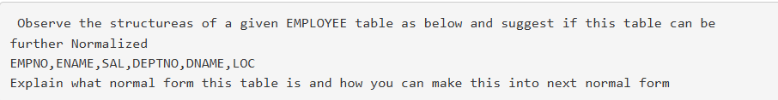

Solution
The given EMPLOYEE table is:
EMPNO | ENAME | SAL | DEPTNO | DNAME | LOC
Step 1: Identify Functional Dependencies
The dependencies in the table are:
- EMPNO → ENAME, SAL, DEPTNO
- DEPTNO → DNAME, LOC
Here, EMPNO is the primary key.
Current Normal Form
Since the primary key is a single attribute (EMPNO), there are no partial dependencies. Therefore, the table is also in 2NF.
Third Normal Form (3NF)
Here: EMPNO → DEPTNO → DNAME, LOC
This is a transitive dependency, so the table is not in 3NF.
Conversion to Third Normal Form (3NF)
To remove the transitive dependency, split the table into two tables:
EMPLOYEE Table
EMPNO | ENAME | SAL | DEPTNO
Primary Key |  |  | Foreign Key
Dependency:
- EMPNO → ENAME, SAL, DEPTNO
DEPARTMENT Table
DEPTNO | DNAME | LOC
Primary Key
Dependency:
- DEPTNO → DNAME, LOC

Question 2:
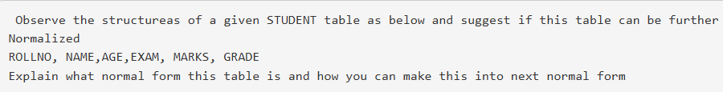

Solution
Assuming:
- ROLLNO → NAME, AGE
- (ROLLNO, EXAM) → MARKS
- MARKS → GRADE
The candidate key is (ROLLNO, EXAM) because a student can take multiple exams.
Current Normal Form
First Normal Form (1NF)
A table is in 1NF if:
- All attributes contain atomic values.
- There are no repeating groups.
The given table satisfies these conditions.
The table is in 1NF.
Second Normal Form (2NF)
A table is in 2NF if:
- It is in 1NF.
- There are no partial dependencies.
Here, the primary key is (ROLLNO, EXAM), but:
- ROLLNO → NAME, AGE
Since NAME and AGE depend only on part of the composite key, there is a partial dependency.
The table is not in 2NF.

Question 3:
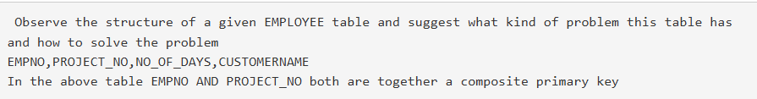

Solution

Given Table:
EMPNO | PROJECT_NO | NO_OF_DAYS | CUSTOMERNAME

Composite Primary Key: (EMPNO, PROJECT_NO)

The table suffers from Partial Dependency because CUSTOMERNAME depends only on PROJECT_NO and not on the entire composite key (EMPNO, PROJECT_NO). Therefore, the table is in 1NF but not in 2NF.

Normalize the table into Second Normal Form (2NF) by decomposing it into two tables:
EMPLOYEE_PROJECT
EMPNO | PROJECT_NO | NO_OF_DAYS
PROJECT
PROJECT_NO | CUSTOMERNAME

